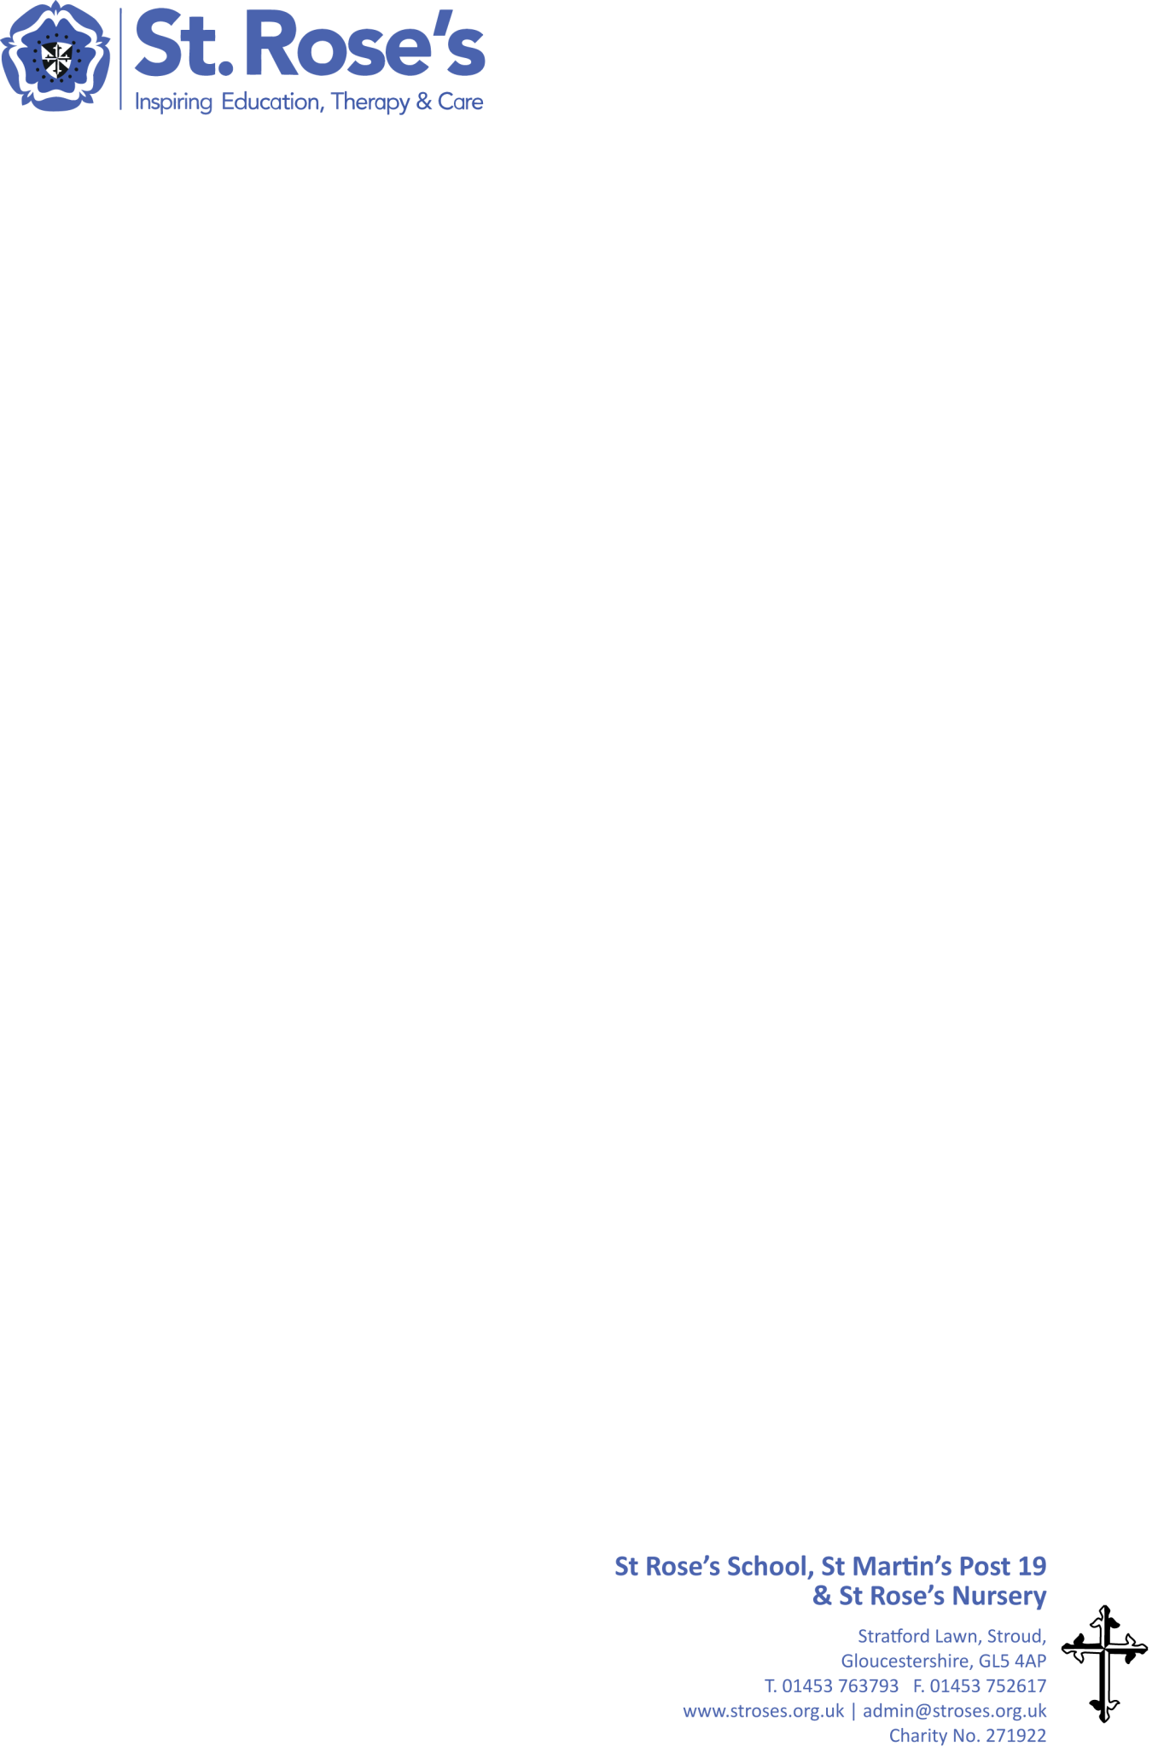**Pathway 2 Curriculum**

it

**IMPLEMENTATION**

**IMPACT**

**INTENT**

Students working towards functional communication, literacy and numeracy. Relevant assessment that measures small steps of progress within a rich curriculum.

Bespoke curriculum matching the abilities and needs of individual students, providing stretch and challenge to maximise their progress and keep every possible learning opportunity open.

Ensure students are engaged and happy and are supported in choices that promote Positive Mental Health. To ensure students have healthy choices and can enjoy a range of quality life experiences.

Students who are prepared for their next learning stages, and who have opportunities to engage within community meaningfully and feel a sense of belonging and purpose.

Through a combination of learning strategies, high and low tech communication aids, and a multi-disciplinary team to support a bespoke curriculum that includes elements of the pre-formal and formal curriculum according to the individual needs and abilities of the student.

A bespoke curriculum for each student based on their specific cognition and physical ability, including sensory integration, incidental curriculum, opportunities to work towards AQA units, topic weeks, focus days, extra-curricular activities and trips.

All medical, physical and sensory needs met by a multi-disciplinary team to maximise range of movement and physical comfort in order to access learning. Specific personal care plans developed in tandem with all relevant therapists to ensure care and education are delivered seamlessly in the school day.

Successful learners who enjoy learning, make progress and achieve.

Assertive individuals who are able to live safe, healthy and happy lives.

Ensure learners can access learning by supporting any complex health needs and maintaining movement range and physical strength.

A Social, Moral, Spiritual and Cultural curriculum that develops the ability to engage in meaningful peer and community interactions, include RSE, Catholic Social Teaching and carefully planned transitions to next stages of learning and life.

Active citizens who can make a positive contribution to the community.