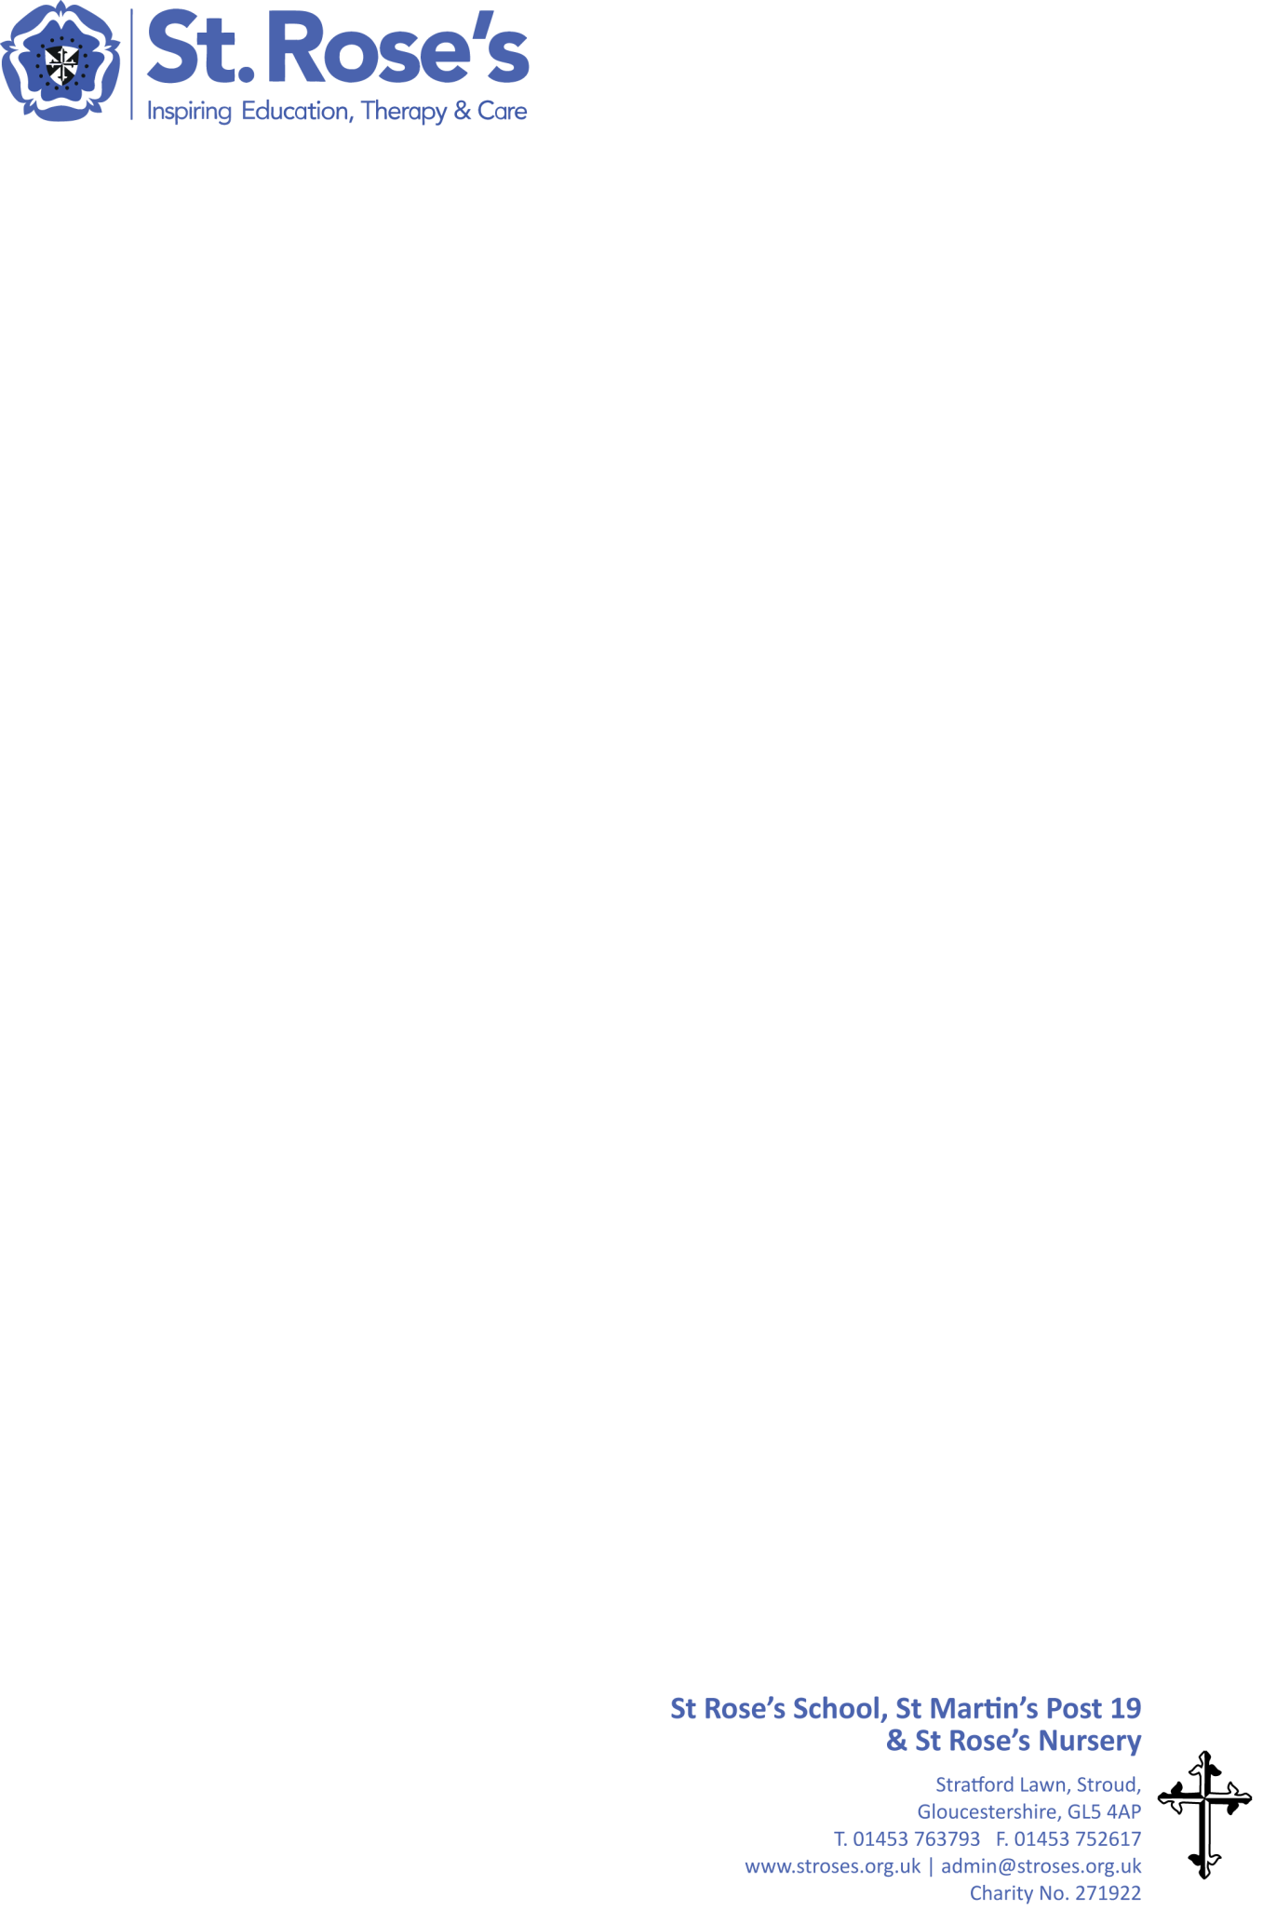**Pathway 1 Curriculum**

Regular opportunities for Social, Moral, Spiritual and Cultural development, PSD, Out in the Community, ASDAN Towards Independence, AQA Unit Awards, Catholic Social Teaching and careful transitions to next stage.

Medical care plans, behaviour plans, training for all staff in all medical interventions, physio therapy, SaLT, aqua, rebound, massage, music therapies, mindfulness, yoga, sensory integration. Qualified nurse on site at all times.

Intensive Interaction, Attention Autism, Sensory story and massage, Objects of Reference, Makaton, AAC, Canaan Barrie on body signs, Sensology, Routes for Learning, MAPP, EHCPs, I.P.s, Incidental Curriculum.

Through a range of low tech and high tech communication aids, strategies and programmes, and a multi disciplinary approach with teachers, SaLT, therapy and care collaborating in the classroom, MDT meetings.

**IMPLEMENTATION**

Support learners to move to their next stages of life with a moral purpose and with community support and involvement.

Enable students to make choices and support their Positive Mental Health. Support learners in achieving ambitious aspirations.

Broad and engaging curriculum that meets the specific and individual needs of each learner and maximise progress.

Holistic progress of each individual student captured accurately to give evidence of small steps of progress.

**IMPACT**

Support learners to develop expressive and receptive communication skills so that they have a voice.

Enable learners to develop independence skills so that they can enjoy as rich and full a social life as possible.

Ensure learners can live a safe, healthy happy life, supporting complex health needs through opportunities to maintain movement and strength.

Help learners to find their place in their community as valued citizens.

**INTENT**