**St Rose’s Nursery**

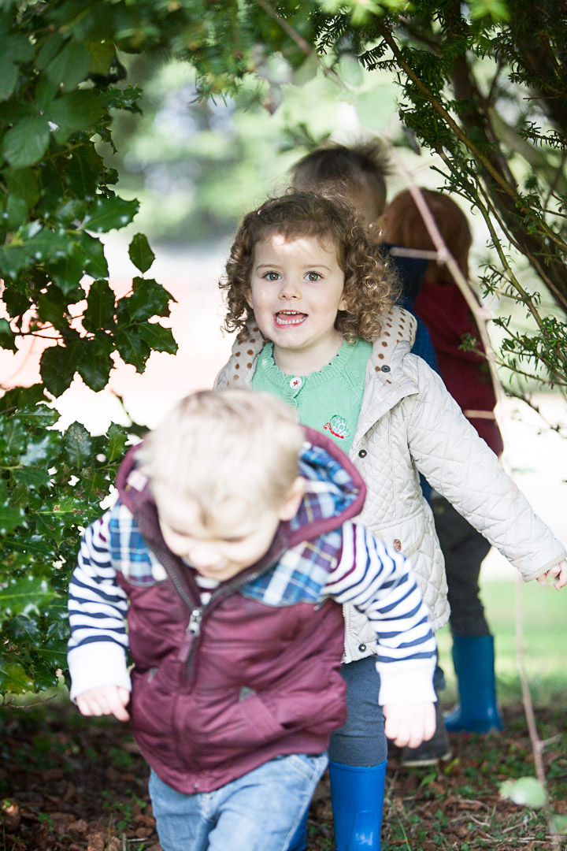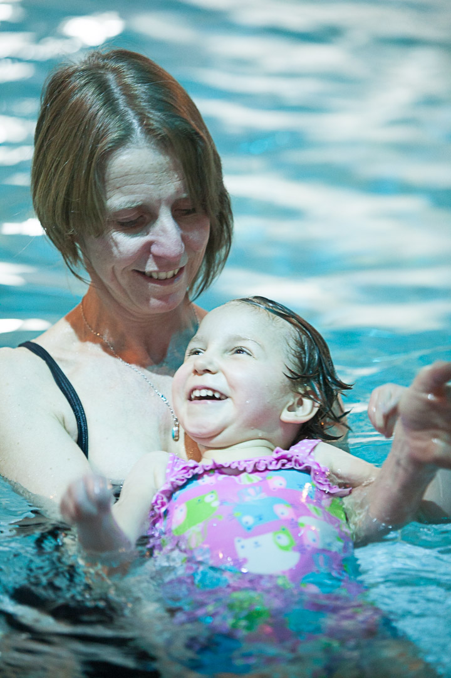

**A fully inclusive nursery for children aged between 2 and 5 years.**

Nursery Manager – Lisa Taylor

St. Rose’s Nursery

Stratford Lawn

Stroud

Gloucestershire

GL5 4AP

**Tel: 01453 763793**

**E:** [**lisa.taylor@stroses.org.uk**](mailto:lisa.taylor@stroses.org.uk)

**W: www.stroses.org.uk**





St Rose’s nursery offers a safe and enabling environment for children aged

between two and five years old, where children with additional needs and

disabilities can learn alongside their peers in a safe, early years environment

* Led by an Early Years Teacher
* Qualified and experienced early years staff
* Staff have specialist training in a wide range of additional needs and
* disabilities
* Access to the full facilities of St Rose’s school including the hydrotherapy
* pool, sensory room and extensive grounds.
* Therapists on site at all times, able to advise nursery staff in supporting
* children’s learning and development.
* Use of the school’s minibuses for regular trips out
* Individual planning and care for every child
* Flexible sessions and able to accept funding for children aged 2, 3 and 4
* years old
* Open term time only
* Toddler group for children aged birth – five

Our unique fully accessible environment means that all children can learn, play, experience and develop alongside their peers no matter what their individual need. At St Rose’s nursery we strongly believe that every child is unique and we adapt our approach to take account of each individual child’s needs. Our qualified, dedicated team of early years practitioners plan individually for each child working in partnership with parents, carers and other professionals.

Within the nursery we follow the Early Years Foundation Stage, a play based framework that encourages children to learn through play, exploring, experimenting, creating and thinking critically. We actively remove barriers to learning, using alternative approaches, equipment and sensory experiences to allow all of our children to have as many positive experiences as possible, learning through play at their own pace and perhaps most importantly having fun!

We also have our own toddler group for children aged from 0-5years where parents, grandparents and their children can come along, meet new friends, get advice and play in our safe environment.

**Nursery Staff**



**Lisa Taylor - Nursery Manager**

Qualification: Postgraduate Certificate in Early Years with Early Years Teacher Status (EYTS)

Lisa has worked at St Roses Nursery in November 2014 having previously been nursery manager for a private full day care nursery. Lisa is the deputy designated safeguarding lead for early years and nursery SENCO. Lisa oversees assessment and learning for all the children in nursery and plans all the trips, visits and special activities that we do. Outside of work Lisa swims regularly and is cub scout leader for 1st Cam Scout group and loves to go camping.



**Jo -** Nursery Deputy

Qualification: NVQ3 Children’s care, learning and development

Jo started at St Roses Nursery in January 2015. Jo was previously a childminder, early years practitioner in a nursery and worked as a teaching assistant in a primary school working with children from reception to year 4 (KS2). Jo has her own baking business and makes the most amazing cakes, pies and pasties and is always keen to get the children cooking and baking.



**Janet -** Early Years Teaching Assistant

Qualification: NVQ3 Teaching Assistant,

Janet has worked at St Roses since 2008 and has worked in all parts of the school. Janet has a wealth of experience in SEN and is always keen to learn more and complete new training. Janet often helps with the schools summer playscheme and is trained in BSL. Janet loves to do lots of exercise classes and spend time with her granddaughter.



**Jess -** Early Years Teaching Assistant

Qualification: NVQ3 Teaching Assistant

Jess has worked at St Roses since 2006 and has worked in all parts of the school before moving to nursery in 2008. Jess has a wealth of experience in SEN and she has previously worked at the National Star college. Jess is a keen runner and has a love of the outdoors. She has been diving and hillwalking all across the UK and in many other countries. She brings that love of the outdoors to nursery and is fantastic at getting the children outside exploring! Jess also has a degree in biochemistry!



**Helena -** Early Years Teaching Assistant

Qualification: NVQ3 Playwork,

Helena has worked at St Roses since 2006 and moved permanently into the nursery in September 2014. Helena is trained in playwork and is also a qualified aromeratherapist. She is also a keen climber and climbs regularly.

All nursery staff have Paediatric first aid training, Child protection and Food hygiene training renewed every three years.

**Nursery Volunteers**

**Wendy**

Wendy helps us with lunch every Tuesday, she is great at teaching the children how to use their cutlery and knowing what they like!

**Dr Subbuswamy (Subbu)**

Subbu volunteers with us on a Tuesday and Wednesday afternoon. The children are very fond of Subbu and love to share stories with him.





**Helene**

Helene helps us with swimming every Wednesday afternoon. The children love to see Helene at the pool and she is great at helping them to be confident in the water.

**Nursery Application Form**

|  |  |  |  |  |  |  |  |  |  |  |  |
| --- | --- | --- | --- | --- | --- | --- | --- | --- | --- | --- | --- |
| Full Name of Child  Date of Birth _________________________ Boy Girl (please tick) | | | | | | | | | | | |
| **Parent/Carer 1**  Name  Relationship  Mobile Phone  Home Phone  Work Phone  E-mail  Home Address  Workplace  Hours of Work | | | | | **Parent/Carer 2**  Name  Relationship  Mobile Phone  Home Phone  Work Phone  E-mail  Home Address  Workplace  Hours of Work | | | | | | |
| **Sessions Required** | Monday | | Tuesday | | | Wednesday | | Thursday | | Friday | |
| Start Date | AM | PM | AM | PM | | AM | PM | AM | PM | AM | PM |
|  |  |  |  |  | |  |  |  |  |  |  |

**Additional Information**

Please provide below any additional information you may feel is relevant at this stage. During your child’s first session at the nursery we will complete a more comprehensive registration document.

In the event of a nursery place being unavailable on the starting date you require, your details will be held on file and you will be contacted as soon as a place becomes available.

**Signed Date**

**Nursery Fees**

* **Morning session £14.00 9 -12 noon**
* **Afternoon session £12.00 1 – 3.30 pm**
* **Hydrotherapy pool (Wednesday pm only) £2.50**
* **Lunchtime hour 12.00-1.00pm £3.50**
* **School Lunch (per day) £2.00**

**Use of the Hydrotherapy pool (Wednesday afternoon only) – additional charge £2.50**

For those children that are with us for our Wednesday afternoon session there is an additional charge made of £2.50 when the early years children have timetabled use of our on-site hydrotherapy pool. This provides the children with a unique opportunity of a fun environment in which to gain water confidence.

**Lunchtime hour**

If your child stays with us for lunch they will be charged for the lunchtime hour, regardless of whether they eat a packed lunch or school lunch

**Fees**

Once a place has been allocated for your child, charges apply even if your child is unable to attend, is unwell or holiday is taken during term time.

**Free for 3 & 4**

Children become eligible for **Free for 3 & 4** funding from the term after their third birthday. The funding enables children to attend a setting for a total of 15 hours per week, for a maximum of ten hours per day. If a child attends 2 settings for more than 15 hours per week, the funding can be shared between both settings, as parents wish.

**Achieving 2 year old funding (A2YO)**

Your child could be entitled to for up to 15 hours of free Nursery Education (criteria apply) from the period after their 2nd birthday. To qualify for this a referral would need to be made by a health professional working with your family, more information can be found on the Gloucestershire Family Service website. If a child attends 2 or more settings for more than the allocated hours per week, the funding can be shared between settings.

**Notice requirements**

Since staffing levels have to be determined in advance, we require four weeks notice if your child no longer requires a place in Nursery.

**St Rose’s Nursery is an inclusive nursery for children aged between 2 and 5 years with or without Special Educational Needs.**

**Individual needs are identified by…**  
the experienced early years staff, who are skilled at identifying a range of special educational needs. If additional needs are identified, a number of steps may be taken to support the needs of each child. These include:

* writing an individual plan, called a My Plan, to identify individual targets, in consultation with parents/carers
* referral to outside agencies where required such as the Advisory Teaching Service, Portage, Community Therapists and Educational Psychologists
* where external support is sought, completion of a My Plan + which will bring together the advice from all professionals involved with the child
* close liaison with external professionals who visit the setting when required
* multi-professional meetings and reviews of My Plan +
* initiation of statutory assessment leading to the provision of an Education and Health Care plan if appropriate.

**We provide…** an inclusive nursery setting which welcomes all children with or without Special Educational Needs. Through our fully accessible facilities we are able to support those children with physical disabilities, sensory, learning and/or communication difficulties including those with complex health needs.

**Our facilities include**:

* a fully accessible site
* Free-flow access to an outdoor play undercover area
* hydrotherapy pool*
* sensory room
* extensive grounds, close to the centre of Stroud, which include a sensory garden with specialised play equipment.
* access to school minibuses which enable us to undertake many trips.

**“The resources are of a very high quality including a number of items of specialist equipment to support children with Special Educational Needs and/or disabilities” OFSTED 2014.**

*provided for an additional charge, unless met through an educational statement or EHC plan

**The Early Years Foundation Stage Framework** The Early Years Foundation Stage (EYFS) sets out the learning and developmental stages for children aged between 0 -5 years. Children are encouraged and supported to learn through play, through a mixture of child initiated and adult led learning. The EYFS is divided into seven areas of learning and development.

**Prime Areas:**

* **Personal, Social and Emotional Development**
* **Physical Development**
* **Communication and Language**

These prime areas are those most essential for your child’s healthy development and future learning. As children grow and develop, the prime areas will help them to develop skills in 4 specific areas.

**Specific Areas:**

* **Literacy**
* **Mathematics**
* **Understanding the World**
* **Expressive arts and design.**

Children in the EYFS learn by playing and exploring, being active, and through creative and critical thinking which takes place both indoors and outside.

**We assess…** the needs and progress of each individual child through the use of:

* continual formative assessment carried out by each child’s key person and the nursery manager
* the Early Years Foundation Stage Development Matters records
* Individual Learning Journey files which document each child’s learning journey
* 2 year old progress checks which are carried out by the child’s key person.

Ongoing observation, assessment and planning ensure that every child is supported to achieve their full potential.

**Parental and student involvement…**

Parents and students at St Rose’s are very effectively involved in planning and reviewing progress in all aspects of need through:

* person-centred approaches to transition planning and annual reviews
* the opportunity to contribute to the Individual Plans that are reviewed every term
* parents’ evenings
* daily liaison through home/school books
* regular face to face contact if possible
* scheduling medical and health-related clinics(orthotics, paediatrician, dietary, sling assessments, wheelchair clinics) in the school
* fundraising activities and events
* social events.

**“Parents are very happy with the care and education their children receive and express they are pleased with the progress their child has made. Parents further comment that the support from staff is ‘fantastic’ and ‘if they have any concerns there is an open door policy’” OFSTED 2014**

**All staff …**

* are qualified to at least NVQ level 3 (or equivalent) for teaching assistants/early years practitioners;
* trained in basic first aid, with all staff having **paediatric first aid** training. In addition, we have nursing staff on site whom we can call on if needed
* up to date with developments with (GCC) early years training courses (including Safeguarding training every 3 years)
* have training in food hygiene.

A very low staff turnover ensures continuity of provision both in terms of relationships, levels of skill and experience.

The school has an effective continual professional development programme for staff which includes regular input on:

* E-safety and ICT skills
* TEACCH teaching techniques
* supporting students with visual impairment and hearing impairment
* specialist teaching techniques for students with profound and multiple learning difficulties
* medical aspects: epilepsy; gastrostomy; anaphylaxis
* eating and drinking guidance and dysphagia
* movement and handling skills
* person-centred philosophies.
* use of communication methods and technologies.

**Transition arrangements…**

When children transition to another setting or to start school, staff complete transition records, as recommended by Gloucestershire County Council. These records include a summative record of the child’s progress and any other information that will enable the child to make a successful transition to school. We encourage local reception staff to visit us before transition to see the children in a familiar environment and to liaise with staff.

**We provide a safe environment by…**

monitoring, evaluating and reviewing practice and provision. Safety is achieved through the implementation of:

* individual moving and handling plans
* individual risk assessments
* individualised health care plans
* classroom/learning area risk assessments
* secure premises
* daily safety checks.

**Beyond the curriculum…**

* the children enjoy regular local visits to the park and local shops
* trips further afield are incorporated into the curriculum and topics we are working on, some of these visits have included: The Sealife Centre, Berkley Castle, Weston Super Mare, Slimbridge Wildfowl and Wetlands Trust and Rove’s Farm
* any visits out are staffed to a very high ratio and supported by parent volunteers to ensure the children’s safety. Visits are risk assessed thoroughly
* we join with the main school for whole-school events such as the school play, Music Prom, Sports Day, and for fundraising events such as Children in Need day.

**How to contact us…** to get in touch, to find out more or discuss an issue, please contact Sheila Talwar, Principal, by any of the methods below.

Email: **admin@stroses.org.uk**

Tel: 01453 763793

Post: St Rose’s

Stratford Lawn, Stroud

Gloucestershire

GL5 4AP

**Further information…**

**about St Rose’s nursery provision is available from**

[www.stroses.org.uk/nursery-ages-2-to-5](http://www.stroses.org.uk/nursery-ages-2-to-5/)